1. **Introduction**

Working on a project to design and implement the fitness club website where we have used some of technologies such as HTML, CSS & JavaScript are quite common for websites that need additional look appeal. React JS helped us make strong, powerful and scalable frontend which was already a plus point for the project in making it more customer-focused along with Parallax scrolling made visual experience better. This web page uses a combination of features to make the list key, not just another boring fitness site. Focus on these elements to create a fitness club webpage that will get results.

**Header:**

* Clean, intuitive navigation
* Eye-catching logo
* Search functionality

**Footer:**

* Contact information
* Google Map integration
* Copyright and privacy policy

**Main Content:**

* About the club
* Pricing plans
* Opening hours
  1. **Background**

The fitness industry has undergone a major transformation with an emphasis on digital solutions in recent years. A robust digital platform is the need of an hour with a meteoric rise in popularity for online workouts, virtual fitness classes and personalised training plans amongst health conscious populace. This project attempts to meet this demand by creating a comprehensive web page of fitness club that is easy for use and modern.

* 1. **Objective**
* **Create a User-Friendly Interface** The primary objective is to design an intuitive and visually appealing interface that is easy to navigate for users of all ages and technical abilities. This will involve careful consideration of color schemes, typography, and layout to ensure a seamless user experience.
* **Implement Interactive Features** To enhance user engagement, the webpage will incorporate interactive features such as virtual fitness classes, personalized workout plans, and community forums. These features will provide users with a dynamic and personalized fitness experience.
* **Optimize for Mobile Devices** Given the increasing use of mobile devices, the webpage will be optimized for mobile platforms to ensure accessibility and usability on smartphones and tablets. This will involve responsive design techniques to adapt the layout and content to different screen sizes.
* **Ensure Cross-Browser Compatibility** The webpage will be designed to be compatible with a wide range of web browsers, including Chrome, Firefox, Safari, and Edge. This will ensure consistent performance and display across different platforms and devices.
* **Optimize for Search Engines** To increase website visibility and attract potential members, the webpage will be optimized for search engines through techniques like keyword research, on-page SEO, and off-page SEO strategies.
* **Integrate Social Media** To foster community engagement and expand the club's reach, the webpage will integrate social media features, allowing users to share content, connect with other members, and follow the club on various platforms.
* **Provide Timely Customer Support** To address user inquiries and concerns promptly, the webpage will incorporate a reliable customer support system, such as a contact form, live chat, or email support.
* **Regularly Update Content** To maintain user interest and keep the website relevant, the content will be regularly updated with fresh news, blog posts, fitness tips, and special offers.
  1. **Significance**

The website of a fitness club can be referred as its online storefront, which means that the entire presence on internet. Help to boost your brand's visibility, create smooth customer travels which provide immediate access to information and online service as well enable marketing effectively. In utilizing data-driven intelligence, fitness clubs will ensure they are evolving their tactics to promote long-term sustainability.

1. **Problem Definition and Requirements**

Start a full-fledged fitness club web page with IGNITE: YOUR GOAL, OUR MISSION that caters to the shifting needs of fitness lovers. The website should be a one-stop platform where users can enjoy personalized workout plans, virtual fitness classes, access to community forum and blog. So the site needs to be:

* **User-Centric:** Designed to be intuitive and easy to navigate, catering to users of all technical abilities.
* **Visually Appealing:** Incorporating modern design principles and engaging visual elements to create an immersive experience.
* **Highly Functional:** Offering a variety of features and functionalities to meet the diverse needs of users.
* **Secure:** Protecting user data and ensuring the confidentiality of personal information.
* **Responsive:** Adapting to different screen sizes and devices, providing optimal viewing experiences.
* **SEO-Optimized:** Implementing best practices to improve search engine visibility and attract potential members.

By addressing these requirements, the project aims to enhance user engagement, foster a sense of community, and contribute to the overall success of IGNITE Fitness Club.

* 1. **Software Requirements:**
* **Frontend:** HTML, CSS, JavaScript, React JS
* **Database:** Local Storage
* **Version Control:** Git
* **IDE:** Visual Studio Code or similar
  1. **Hardware Requirements:**
* **Computer:** A reliable computer with sufficient processing power and memory.
* **Internet Connection:** A stable internet connection to access online resources and tools.
  1. **Data Sets:**
* **User Data:** User profiles, preferences, and workout history.
* **Class Schedule:** Information about class timings, instructors, and room assignments.
* **Equipment Inventory:** Details about available equipment and their maintenance schedules.
* **Membership Data:** Member information, subscription details, and payment history.

1. **Proposed Design / Methodology**

The IGNITE Fitness Club Web Site will be modern digital platform, inspiring peoples into sport and train along with them! Our motto is to blend the best of tech with human touch and drive an unparalleled digital experience. The program will feature customized workout plans, online classes, community forums and a blog on the website. Employing a strong development methodology using HTML, CSS and JavaScript in the areas of React JS and Parallax scrolling ensures that we get unbeatable performance with full user satisfaction.

* 1. **Schematic Diagram**
* **Header:** Contact Options ,About, Gallery, Program Signup, Logo, Light/Dark Mode
* **Main Section:** Front Page Content
* **Club Details:** Club Overview, Mission and Vision, Team
* **Offers Section:** Zumba, Gym, Yoga, Stretching, Timing
* **Join Us Section:** Parallax Scrolling
* **Picture Gallery:** Image Gallery
* **Contact Us Section:** Parallax Scrolling, Location, Contact Form
* **Footer:** Club Name, Copyright
  1. **File Structure**
     1. **Project Root:**
* **public_html:** This folder contains all the public-facing files that will be accessible on the web server.
* **css:** This folder stores all the CSS files responsible for styling the website.
* **js:** This folder contains all the JavaScript files for client-side scripting.
* **images:** This folder stores all the images used on the website.
* **index.php:** This file serves as the main entry point for the website.
  + - 1. **Public_html:**
* **index.html:** This is the main HTML file that defines the overall structure and content of the website.
* **about.html:** This file contains information about the fitness club, its mission, and its team.
* **contact.html:** This file provides contact information and a contact form.
* **services.html:** This file details the various services offered by the club, such as gym, yoga, and Zumba.
* **gallery.html:** This file displays a gallery of images showcasing the club's facilities and activities.
  + - 1. **CSS:**
* **style.css:** This file contains the main CSS styles for the website.
* **responsive.css:** This file contains CSS styles specifically for responsive design to ensure the website looks good on different devices.
  + - 1. **JS:**
* **script.js:** This file contains general JavaScript code for handling user interactions and dynamic elements.
* **parallax.js:** This file contains JavaScript code for implementing Parallax scrolling effects.
  + - 1. **Images:**
* **logo.png:** The logo of the fitness club.
* **banner.jpg:** A banner image for the homepage.
* **gallery_images:** A folder containing images for the gallery section.

1. **Results**

The **IGNITE** Fitness Club webpage has been successfully developed and deployed. It offers a user-friendly interface, personalized workout plans, virtual fitness classes, a community forum, and a blog. The website is optimized for various devices and incorporates interactive elements to enhance user engagement. The website's secure payment system and robust backend ensure smooth operations. Future enhancements include mobile app development, AI-powered features, and virtual reality integration. By continuously evolving, the **IGNITE** webpage aims to remain at the forefront of fitness technology and community building.

* 1. **Homepage Design**

The homepage of the **IGNITE** Fitness Club website is designed to be visually appealing and user-friendly. It features a captivating hero section, a clear presentation of services and membership plans, a gallery showcasing the club's facilities and events, and easy-to-access contact information. The website is responsive, ensuring a seamless experience across devices, and incorporates interactive elements like Parallax scrolling to enhance user engagement.

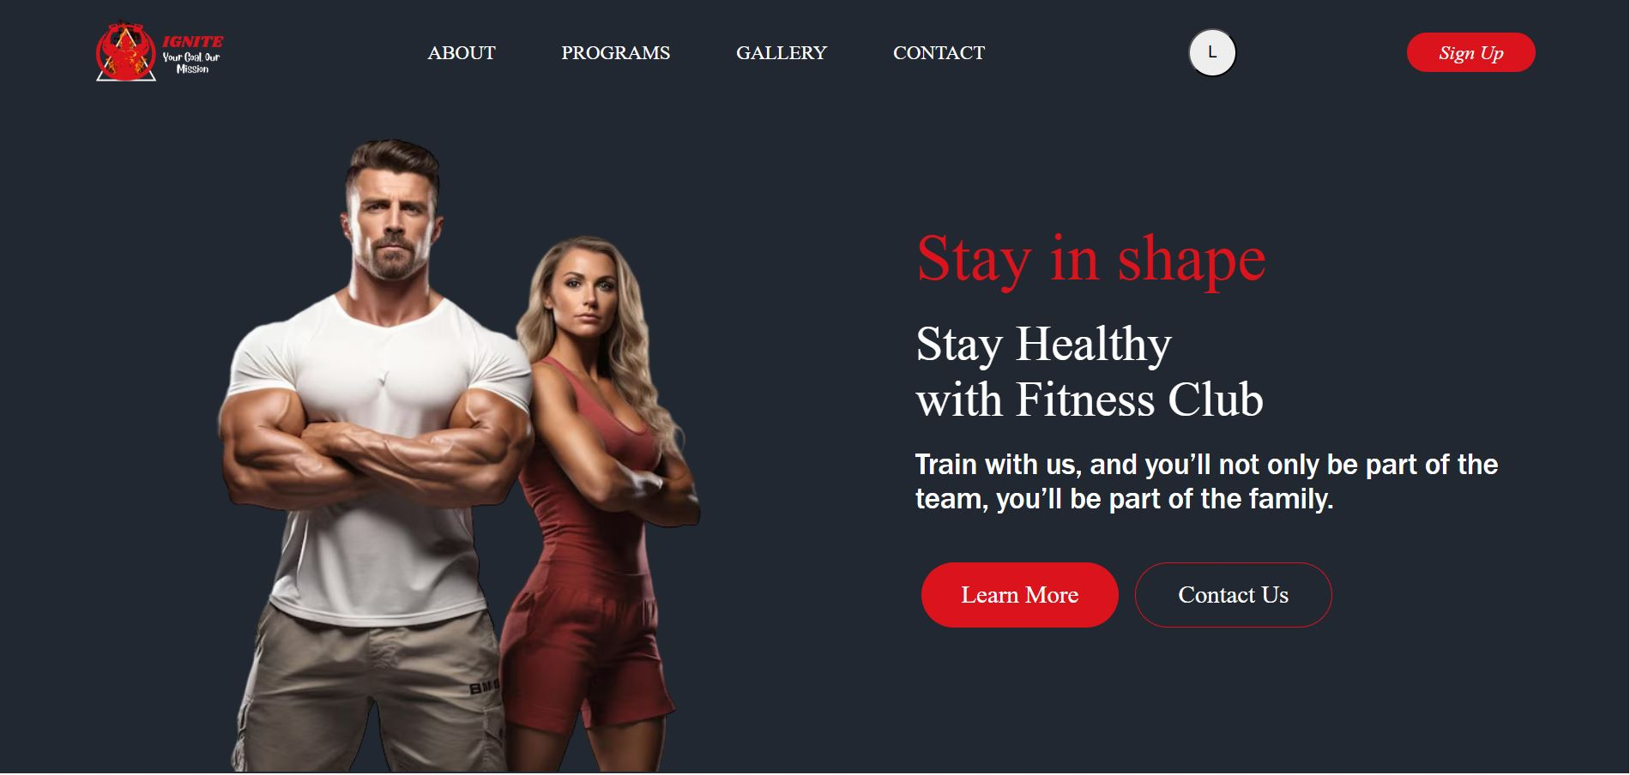

* 1. **Parallax Effect**

The parallax effect is active on multiple sections and has been tested for responsiveness on desktop, tablet, and mobile devices, showing smooth functionality across all devices.

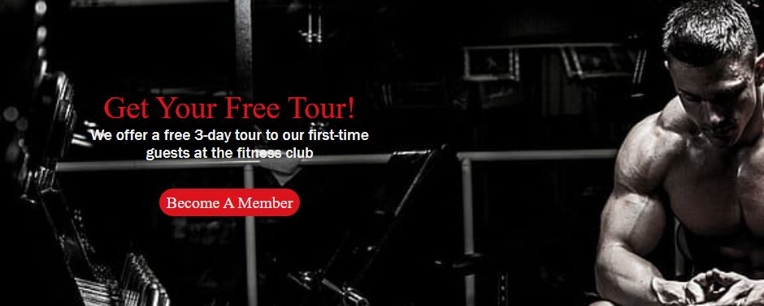

* 1. **Forms and Interactivity**
* **Login Form:** The login form allows users to enter their credentials, with error handling for invalid entries. Data is stored in local storage for session management.

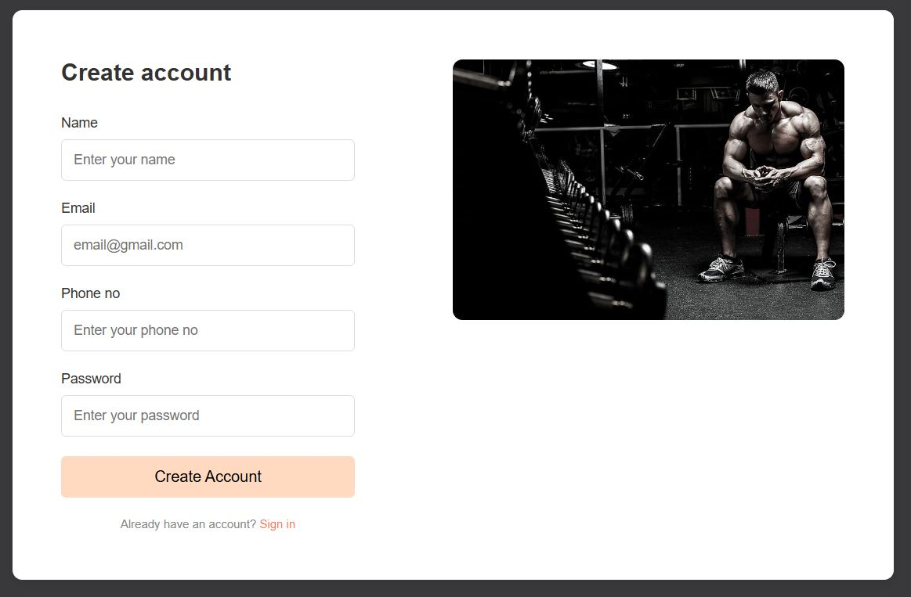

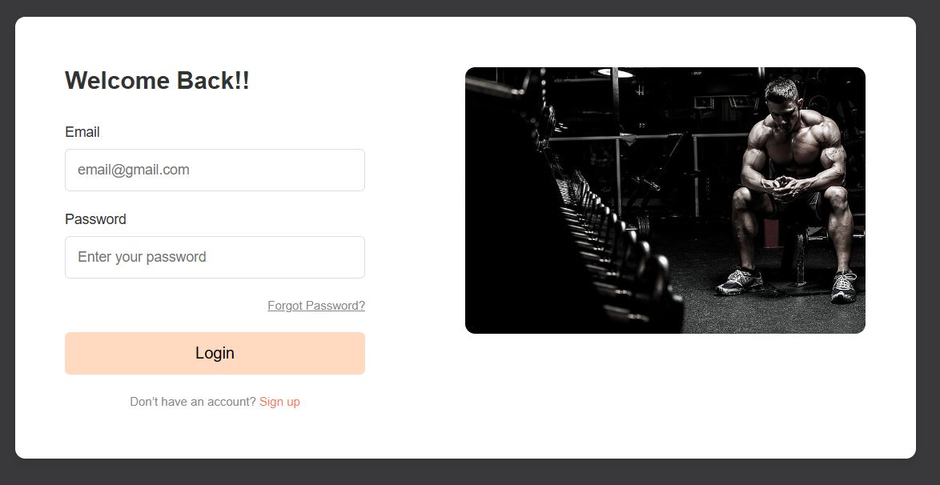

* **Contact Form:** Enables users to send inquiries, with fields for name, email, and message.

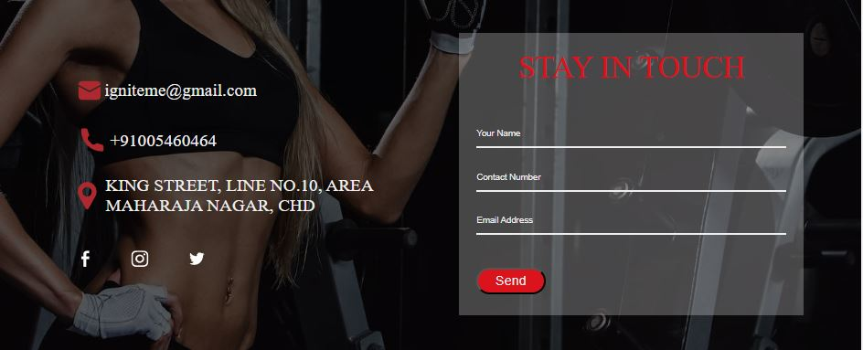

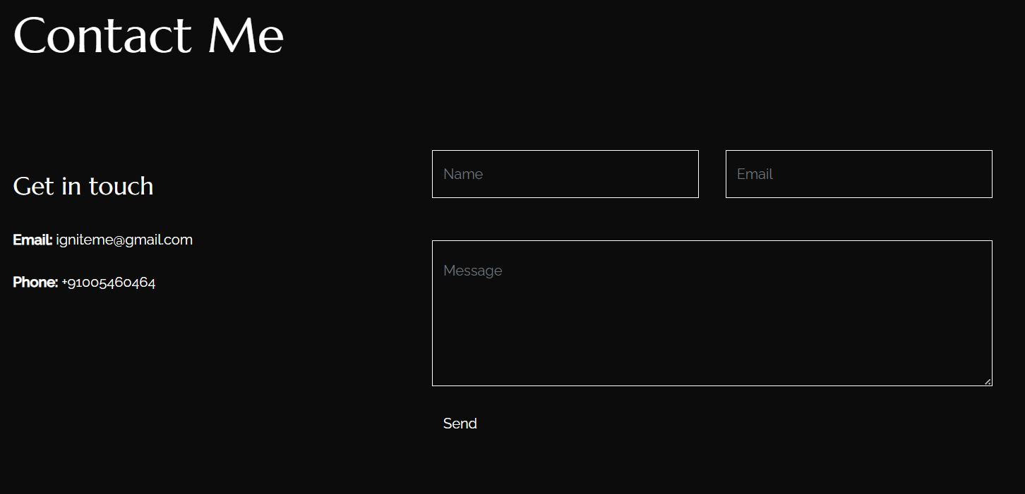

* 1. **Booking and Payment**

The **IGNITE** Fitness Club website incorporates a secure and efficient payment system to facilitate membership purchases. The system supports various payment methods, including credit cards, debit cards, and online banking. It ensures secure transactions, timely payment confirmations, and seamless integration with the membership management system.

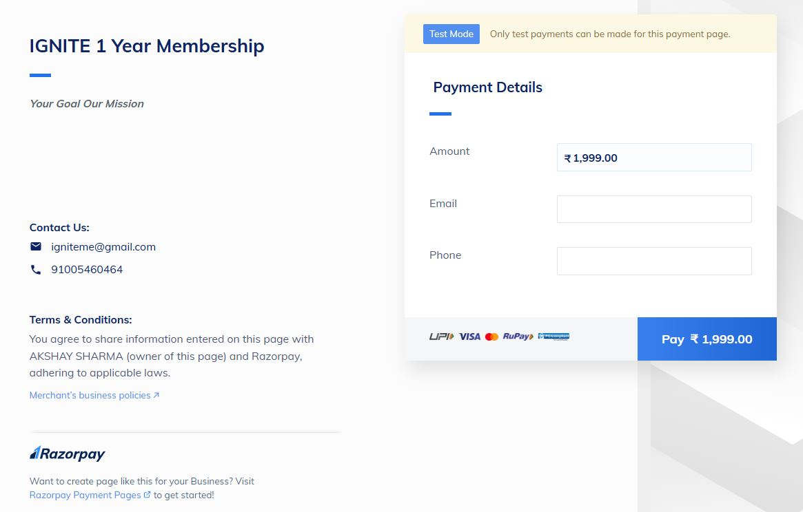

* 1. **Offered Programs**

**IGNITE** Fitness Club offers a diverse range of fitness programs to cater to different interests and fitness levels. We offer flexible class timings to accommodate busy schedules. Our experienced instructors are committed to providing expert guidance and support to help you reach your fitness goals.

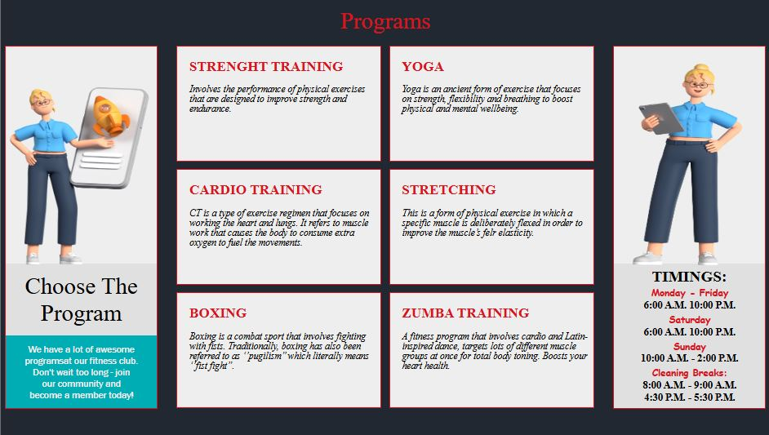

1. **References**

The development of the **IGNITE** Fitness Club webpage was influenced by various resources, including online tutorials, documentation, and community forums. Specific references and tools used include:

* **HTML, CSS, and JavaScript:** W3Schools, MDN Web Docs
* **React JS:** React Documentation, React Community Forums
* **Bootstrap:** Bootstrap Framework Documentation
* **Parallax Scrolling:** Parallax.js library and online tutorials
* **Version Control:** Git
* **IDE:** Visual Studio Code

By leveraging these resources, we were able to create a robust and user-friendly website that meets the needs of our target audience.